Road Warrior IT Security Training Exam
Multiple Choice. Read each question and answer carefully and select the BEST answer:
- You are less likely to experience an IT security incident when travelling:
  - True
  - False
- Why is IT Security important?
  - We have a duty
  - Data breaches cost a lot of money in downtime and fines
  - It’s the law
  - All of the above
- Cyber criminals are really only looking for bank account details.
  - True
  - False
- How can you better protect your user account?
  - Use a complex password
  - Use Multi-Factor Authentication
  - Change your password when you think you’ve been compromised
  - All of the above

- Mutli-Factor Authentication is defined as:
  - Having multiple people know your password in case you forget it.
  - Being challenged to approve a login after providing your password.
  - Not using a password when logging in.
- Which of the following is NOT correct when it comes to data security?
  - Device encryption provides no protection to sensitive data on a device.
  - You should always secure your mobile phone with a passcode.
  - You should never leave your laptop unattended.
  - Only allow someone you know and trust to access your computer.
- Which of the following is a “red flag” that your account/identity may have been compromised?
  - You have lost access to your online accounts.
  - You stop receiving a utility bill.
  - You get an e-mail from a friend/colleague that you sent them a strange e-mail.
  - All of the above.
- Phishing is a type of social engineering.
  - True
  - False
- What is phishing?
  - A great way to relax and unwind after a long week of auditing.
  - At attack vector designed to steal your information by impersonating someone or something.
  - An attack vector designed to hack into a computer system using a sophisticated computer program.
- How can you identify a phishing e-mail?
  - By hovering over links to see where they take you.
  - By examining the sender and recipients.
  - Downloading and opening attachments.
  - Both A & B
- Look at the following phishing e-mail. Please provide 2 red flags that the message is not legitimate.
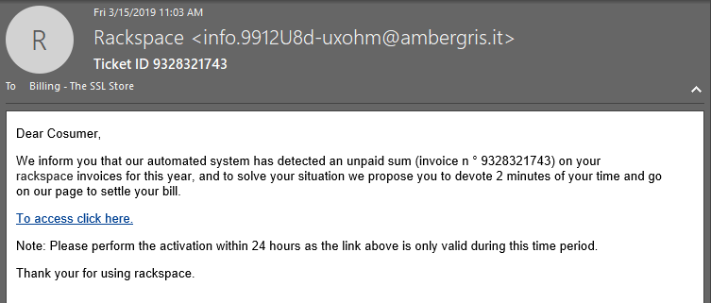
  - [Type an answer here]
  - [Type an answer here]
- What is Link Manipulation?
  - A sophisticated phishing attack.
  - A mistyped web address that resembles a correct address.
  - A link to a seemingly legitimate website at time of send, but after a few days the website starts hosting malware.
  - All of the above.
- Which of the following is NOT a technique of Social Engineering?
  - Using your publicly available information in order to fool into thinking something is legitimate.
  - Straight up lying to you or someone to get information.
  - Phishing
  - Connecting to a mobile hotspot.
- When a security incident occurs, you should:
  - Ask if a data breach occurred.
  - Disconnect from the Internet.
  - Call the SQA IT Manager.
  - All of the above.
- Keeping your computer operating system and applications up to date is a great way to maintain data security.
  - True
  - False
- Which of the following Tips & Tricks are the most important to you?
  - Use a secure password manager.
  - Use a good up-to-date antivirus.
  - Avoid Unsecure WiFi and opt to use a mobile hotspot if you have one.
  - Use your Smithers e-mail for business-related activity, not for coupons or fantasy football.
  - Stay Vigilant
- One thing I would like to learn more about IT security is:
  - [Type an answer here]

