Module #1 – Post Training Exam
NAME:
Minimum 80% required to pass.
- In light of ICOP Resolution log #155, which of the following AS/ISO scopes would NOT be acceptable:
  - AS Scope: Design and Manufacturing of bars, tubes and shapes in copper alloys.
ISO Scope: Design and Manufacturing of bars, tubes and shapes in copper alloys.
  - AS Scope: Supplier of fasteners/hardware and services including assembly, kitting and inspection to the Aerospace industry.
ISO Scope: Supplier of fasteners/hardware and services including assembly, kitting and inspection to the Aerospace and various Commercial industries.
  - AS Scope: Manufacture and supply of printed circuit boards.
ISO Scope: Manufacture and supply of printed circuit boards.
  - All are acceptable.
- Scenario: An excess amount of PEARs, NCRs are incurred towards the end of the Audit activity. What is the appropriate action?
  - Contact the office.
  - Carve out some additional time from Audit follow-up’s and accommodate with the time provided.
  - Stay over an hour or two to address what needs to be done.
- Top Management must be covered as part of any on-site audit activity and denoted appropriately on the Audit Plan.
  - True.
  - False.
- Not Applicable denotations must be carried through on the following:
  - CRW, Audit Plan, Audit Report
  - CRW, Audit Plan, QMS Matrix, Audit Report, OASIS Certificate listed information
  - CRW, Audit Plan, QMS Matrix, Audit Report
- Denote with an ‘X’ any incorrect website examples.
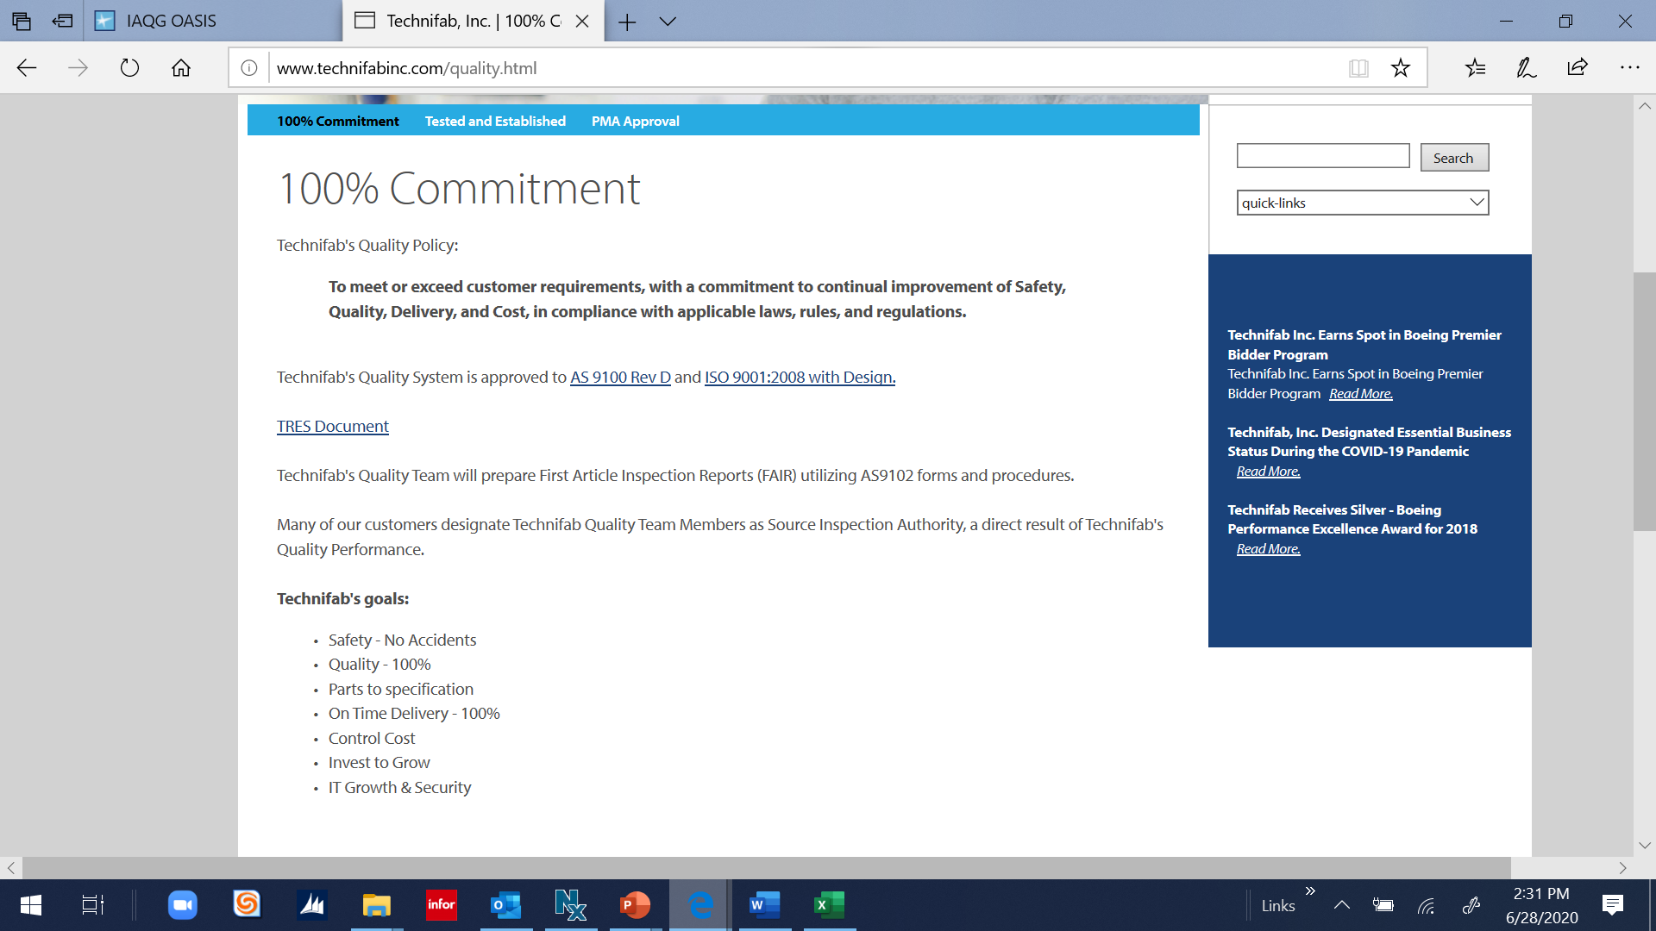
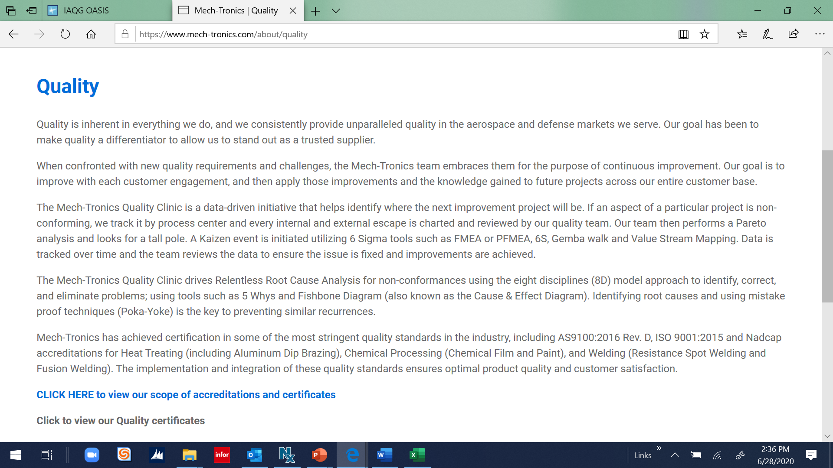
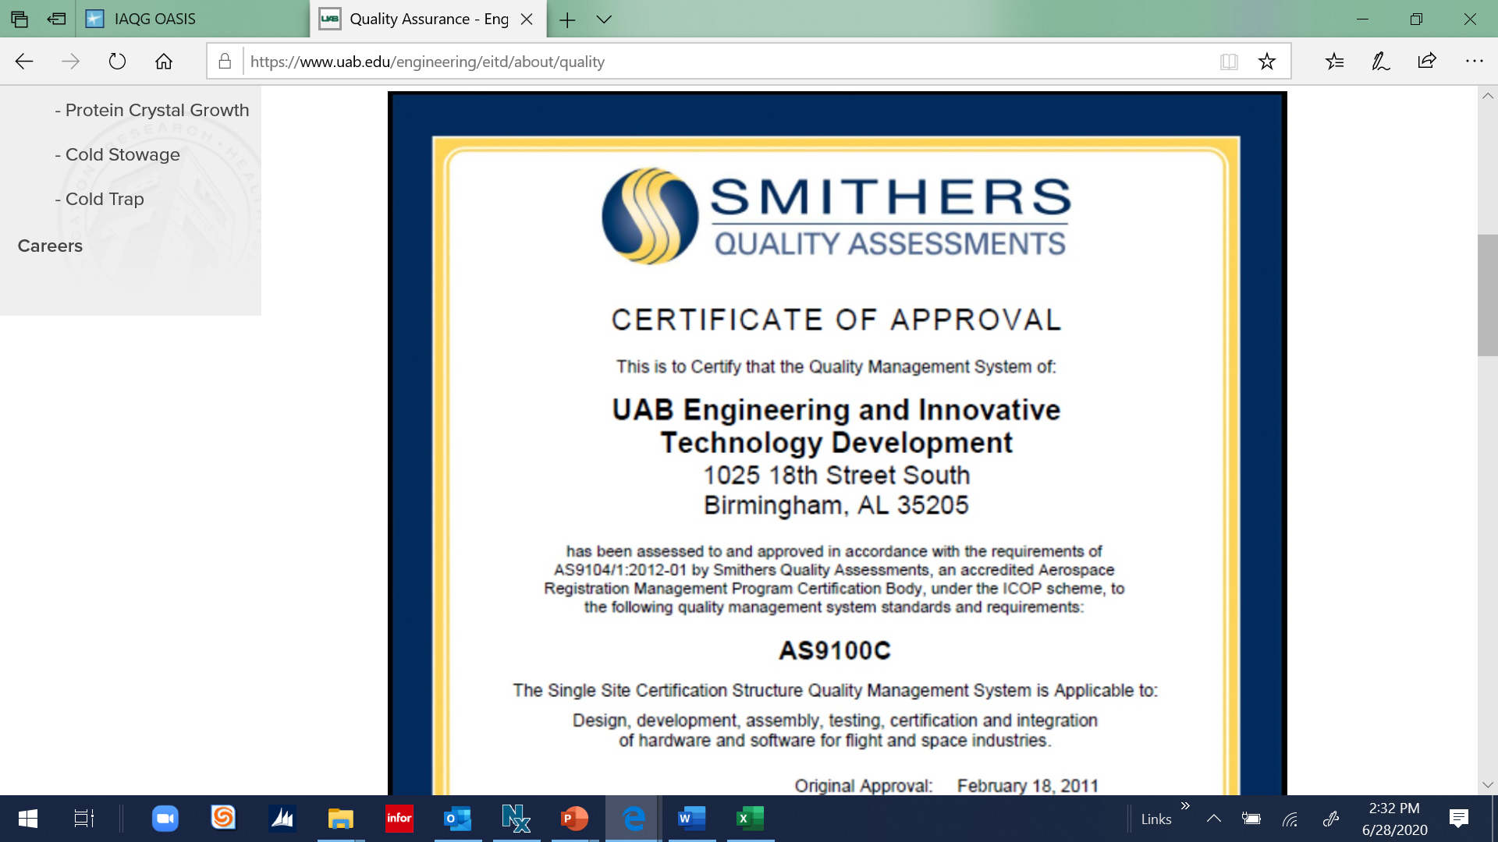
- Identify any deficiencies with the following NCR with an X in the right column:
7 | Issue Date | 4/30/20
10 | Process | Manufacturing
12 | Statement of Nonconformity | Manufacturing Process is not entirely effective for the availability of documented information that supports controlled conditions.
13 | Objective Evidence | Various documents observed ‘uncontrolled’.
14 | Containment Required? | No.
15 | Due Date | (blank)
19 | Containment Action(s) | (blank)
20 | Correction(s) | Corrected documentation appropriately.
23 | Root Cause | NEW QM was not familiar with document control requirements.
25 | Corrective Action(s) | Signed up QM for a training to be supported in August 2020.
26 | Planned Completion Date | 6/30/20
27 | Actual Completion Date | 7/15/20
30 | Details (Auditor Verification and NCR Closure) | Will continue to verify the effectiveness of the CA at the next scheduled audit activity.
- Identify any deficiencies with the following NCR with an X in the right column:
7 | Issue Date | 1/30/20
10 | Process | Design
12 | Statement of Nonconformity | Design Process is not entirely effective in ensuring appropriate design change orders are verified for requirements fulfilled prior to changepoint in Production.
13 | Objective Evidence | Following design change orders noted as not verified (prior to production release): 12SWa (change in dimensional drilling hole locations); 2XCYd (change in material thickness, per customer request); 4RT2 (location holes moved)
14 | Containment Required? | No.
15 | Due Date | 3/30/20
19 | Containment Action(s) | (blank)
20 | Correction(s) | Reviewed the ‘Design Release’ IT system for any possible other design change order verification reviews missed. Did not find any.
23 | Root Cause | Final step of Design release process is supposed to be a Design/Operations ‘gated’ review for assessment of any requirements fulfillment and this process step was missed through the ‘Design Release’ IT system. Upon further examination, the ‘Design Release’ IT system had this review disabled which allowed these changes to go to release without this requirement fulfilled.
25 | Corrective Action(s) | IT will permanently remove the disable feature for assessment of requirements fulfilled with the Design/Operations ‘gated’ review in the ‘Design Release’ IT system.
26 | Planned Completion Date | 3/15/20
27 | Actual Completion Date | 3/1/20
30 | Details (Auditor Verification and NCR Closure) | Verified a sample of (6) design change orders (including 16KL2, 204Fa, 3302a, 6T129, Y4589, E73jA) with supporting requirements in place for the Design/Operations ‘gated’ review in the ‘Design Release’ IT system. Found no issues. Will continue to verify effectiveness at next scheduled audit activity.
- Pre-Audit Planning information is required for all Audits.
  - True.
  - False.
- Identification of shift coverage is not required within Audit Plans.
  - True.
  - False.
- Identify any of the following unacceptable Certificate Scope statements.
  - Johnson Machining is a high caliber, state of the art Machine operation that manufactures cast iron arm joints.
  - Design and Manufacture of parts for the Aerospace industry.
  - Manufacture of copper nickel alloy flat wire for the Aerospace industry.
  - A and B.

